CPE301 – SPRING 2019

Design Assignment 2B

Student Name: Benjamin Johnson

Student #: 5003284489

Student Email: johnsb18@unlv.nevada.edu

Primary Github address: https://github.com/johnsb18/ClassRepository

Directory: ClassRepository/DesignAssignments/DA2B

Submit the following for all Labs:

1. In the document, for each task submit the modified or included code (only) with highlights and justifications of the modifications. Also, include the comments.
2. Use the previously create a Github repository with a random name (no CPE/301, Lastname, Firstname). Place all labs under the root folder ESD301/DA, sub-folder named LABXX, with one document and one video link file for each lab, place modified asm/c files named as LabXX-TYY.asm/c.
3. If multiple asm/c files or other libraries are used, create a folder LabXX-TYY and place these files inside the folder.
4. The folder should have a) Word document (see template), b) source code file(s) and other include files, c) text file with youtube video links (see template).

1. **COMPONENTS LIST AND CONNECTION BLOCK DIAGRAM w/ PINS**
2. **INITIAL/MODIFIED/DEVELOPED CODE OF TASK 1/A**

; GPIO IRQ_ASM.asm

;

; Created: 3/9/2019 4:58:56 PM

; Author : Benjamin Johnson

; Student #: 5003284489

; Email: johnsb18@unlv.nevada.edu

.org 0 ; location for reset

jmp MAIN

.org 0x02 ; location for external interrupt INT0

jmp EX0_ISR

MAIN:

ldi R20, HIGH(RAMEND) ; initialize stack

out SPH, R20

ldi R20, LOW(RAMEND)

out SPL, R20

ldi R20, 2 ; make INT0 falling edge triggered

sts EICRA, R20

sbi DDRB, 2 ; set PORTB.2 as output

sbi PORTB, 2 ; set LED off

sbi PORTD, 2 ; turn on pull-up

cbi DDRC, 2 ; set PORTC.2 as input

sbi PORTC, 2 ; enable pull up

ldi R20, 1<<INT0 ; enable INT0

out EIMSK, R20

sei ; enable interrupts

WHILE:

jmp WHILE ; wait for interrupt

EX0_ISR:

in R21, PORTB ; R21 = PORTB

ldi R22, (1<<2) ; load mask for toggling

eor R21, R22 ; toggle LED

out PORTB, R21 ; PORTB = R21

; Delay 20 000 000 cycles

; 1s 250ms at 16 MHz

ldi r18, 102

ldi r19, 118

ldi r20, 194

L1: dec r20

brne L1

dec r19

brne L1

dec r18

brne L1

reti ; return from interrupt

--------------------------------------------------------------------------

/*

* GPIO IRQ_C.c

*

* Created: 3/9/2019 1:50:27 PM

* Author : Benjamin Johnson

* Student #: 5003284489

* Email: johnsb18@unlv.nevada.edu

*/

#define *F_CPU* 16000000UL

#include <avr/io.h>

#include <avr/interrupt.h>

#include <util/delay.h>

int main(void)

{

DDRB |= (1<<2); // set PORTB.2 for output (LED)

PORTB |= (1<<2); // set LED low

DDRC &= (0<<2); // connect PORTC.2 to switch as input

PORTC |= (1<<2); // enable pull-up

EIMSK = (1<<INT0); // enable external interrupt 0

EICRA = (1<<ISC01); // make INT0 falling edge triggered

sei (); // enable interrupts

while (1) {} // wait for interrupt

}

ISR (INT0_vect) { // ISR for external interrupt INT0

PORTB ^= (1<<2); // toggle PORTB.2 (LED)

*_delay_ms*(1250); // delay for 1.25 sec

}

1. **DEVELOPED MODIFIED CODE OF TASK 2/A from TASK 1/A**

Insert only the modified sections here

1. **SCHEMATICS**
2. **SCREENSHOTS OF EACH TASK OUTPUT (ATMEL STUDIO OUTPUT)**

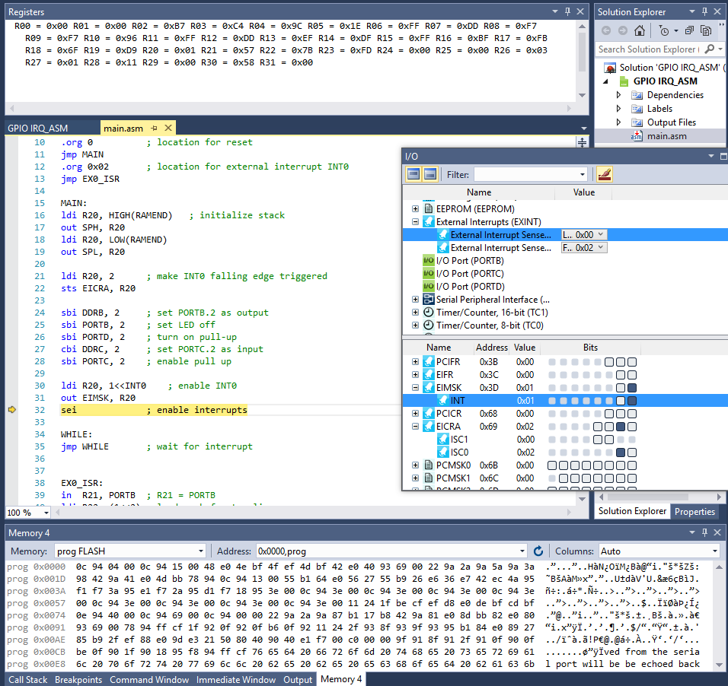

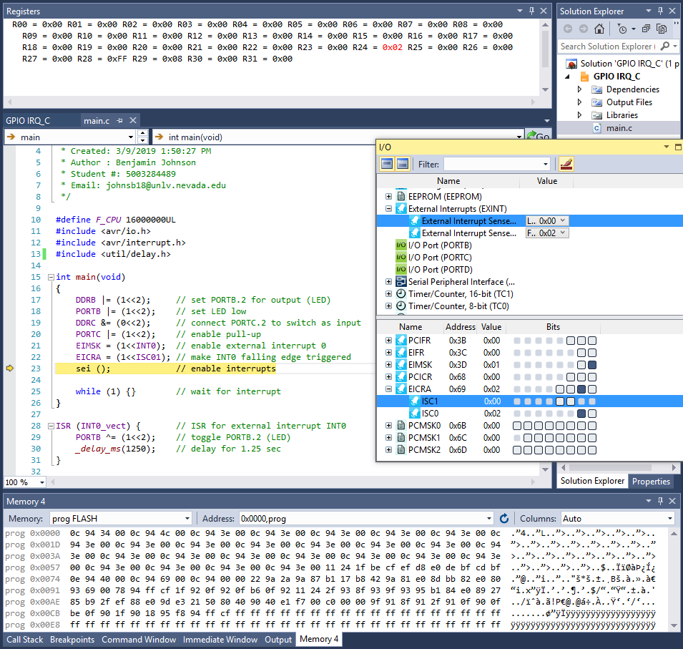

1. **SCREENSHOT OF EACH DEMO (BOARD SETUP)**

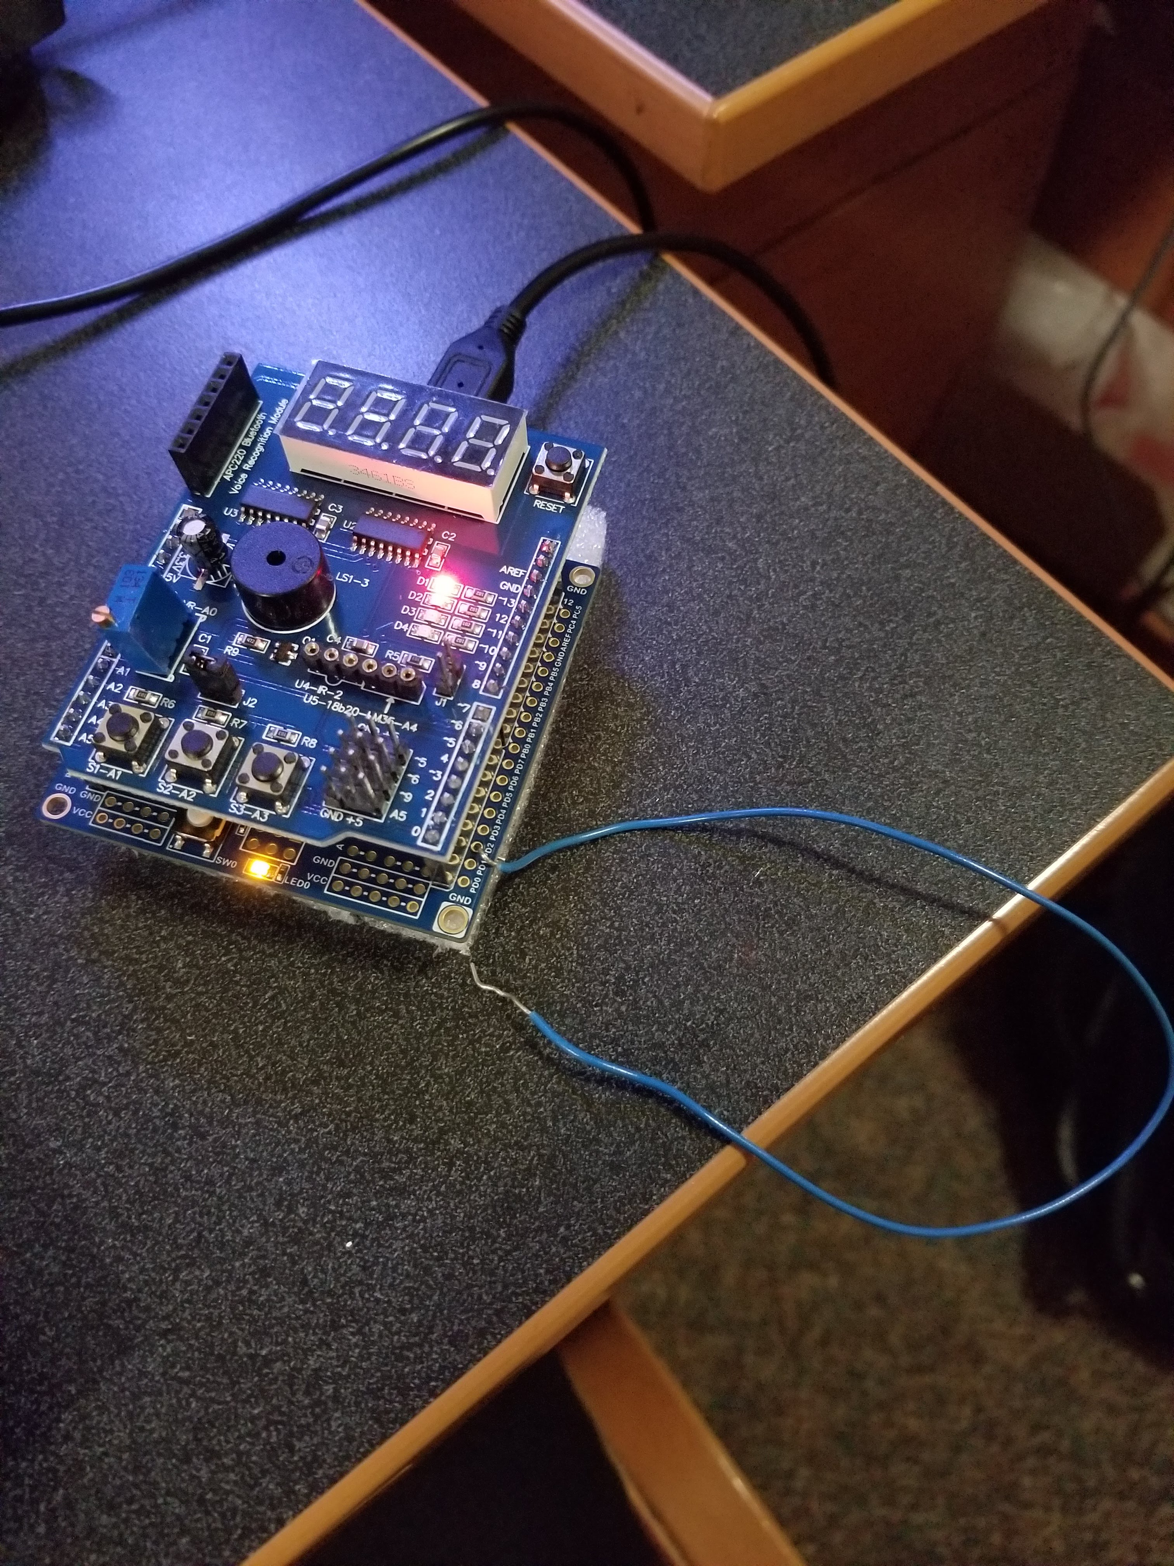

1. **VIDEO LINKS OF EACH DEMO**

https://youtu.be/J47CX-IcE50

1. **GITHUB LINK OF THIS DA**

https://github.com/johnsb18/ClassRepository/tree/master/DesignAssignments/DA2B

**Student Academic Misconduct Policy**

<http://studentconduct.unlv.edu/misconduct/policy.html>

“This assignment submission is my own, original work”.

Benjamin Johnson